Source: http://www.takakaira.co.jp/performance/defi/dl/bfmeter/bfmain.htm
Main Product Features

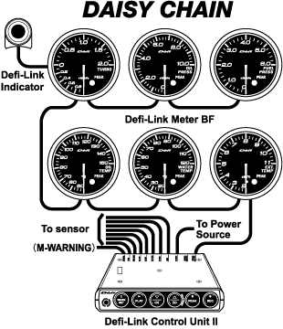

Daisy Chain Connection
a) Multiple Interface System
Uses only one wire to send power, light, ground, and data to and from all seven gauges. All gauges and the control unit have separate microcomputer units.

b) Easy installation
Installing additional gauges involves simply connecting the gauges together and wiring the sensor to the control unit.

c) Easy operation
Gauges can be mounted in remote location in the vehicle but can be controlled with the control unit. It is possible to connect up to 7 gauges to one control unit. Using only one switch, it is possible to display memory replay, peak memory, and warning set values on all gauges.

d) Low cost
It is not necessary to purchase additional control units when installing additional gauges.
DAISY CHAIN allows up to 6 Defi-Link Meter BFs or up to 7 Defi-Link Meters to be connected to one Control UnitII.
DAISY CHAIN connection can not be applied to connection between Defi-Link Meter BFs and Defi-Link Meters.

Stepping Motor

a) Quick response
Gauge's needle pointers are driven by a micro computer controlled stepping motor that has smooth instantaneous response to rapid accelerations of high performance vehicles.

b) High precision and light weight
The angle of deflection of the instrument needles is controlled by the microcomputer. The maximum angle of deflection of 270 is controlled in steps of 0.12‹ to provide a high precision display of engine diagnostics.
Compared to similar products from other companies, this product is 30% lighter.

c) Freedom of installation
There is no "dumping of oil". The motor can be installed at any angle.

Multi-functional

a) Wiring check function
The presence of any cut wires, short circuits, and communication errors are checked and possible areas of fault are checked.

b) Memory play function
Driving data is stored into the memory at the gauge.

c) Warning function
A warning value can be set. When this value is exceeded, a red warning LED comes on and a buzzer sounds at the same time.
It is possible to connect a Defi-Link indicator(sold separately) to each gauge. This indicator, 25mm radius, can be connected to M-WARNING connector of Control Unit II to increase the visibility.

d) Peak memory function
The gauges record the maximum vehicle speed in memory, for later review.

e) Opening mode
Illumination of gauge dial, needle pointer, and each LED are turned on being interlocked with ignition switch on. After the illumination is turned on, it goes out once and then goes on again.

f) Closing mode
Illumination of gauge dial, warning LED peak LED, and needle pointer are gradually goes out after the ignition switch is turned off.

g) Brightness adjustment
Brightness can be adjusted. There are 10 stages of brightness, 5 stages in the daytime and 5 stages in the nighttime. The brightness decreases being interlocked with the illumination switch on.

Attractive design

a) Bezel
The Bezel hairline is finished with an alumite process which gives it a high gloss surface.

b) LED Lamps
The indicator lights are high intensity red LED lamps.
Gauge dials are invisible while the ignition switch is off. Once the ignition switch is turned on, clear display appears with white LED illumination.

c) Red emitting needle pointer
White gauge illumination and red emitting needle pointer increase visibility.

