Found at: http://www.c-speedracing.com/howto/b18cclutch/clutch.php

How to change transmission on a B18C

1: Disconnect both the battery negative and positive.

2: Drain the transmission fluid.

3: Remove the axels on both sides.

4: Remove the shift linkage.

5: Remove the splash shield.

6: Loosen the exhaust.

7: Remove the air intake.

8: Remove the clutch slave cylinder.

9: Disconnect all the wiring from the transmission.

10: Remove the starter.

11: Remove the main bolts that hold the transmission to the block.

12: Loosen the rear engine mount.

13: Place a jack under the engine.

14: Remove the lower right engine mount.

15: Remove the upper right engine mount.

16: Loosen both the left engine mounts

17: Slowly let the motor drop down by lowering the jack until the motor sits sideways in the engine bay.

18: Separate the transmission from the block and carefully lower it to the ground.

19: Remove old throw out bearing

20: Install new throw out bearing

1: Disconnect both the battery negative and positive terminals.
Disconnect both the battery negative and positive terminals.

2: Drain the transmission fluid.
Drain the transmission fluid.

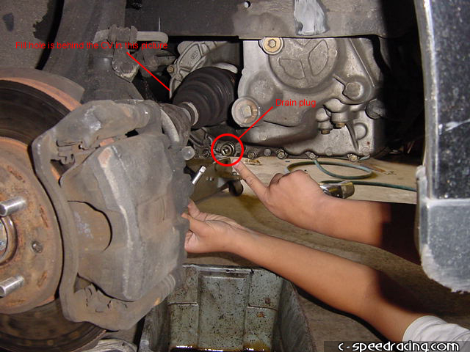

3: Remove the axels on both sides.
The first step in removing the axels is removing the ball joint. Sometimes it can be difficult to remove the ball joint, so grab a mallot and hit it on the lower control arm where the ball seats. Don't hit the stud, you will mushroom it.

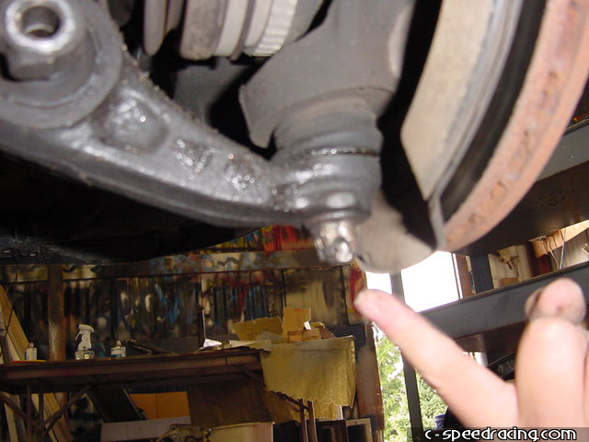

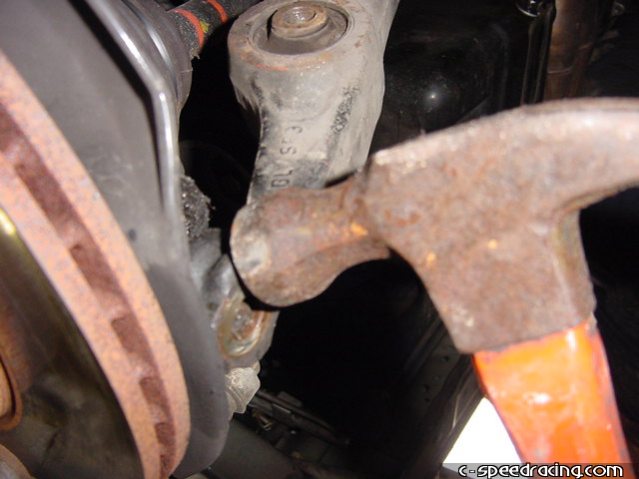

A perhaps better way to remove the ball joint is to jack up the suspension, using the brake rotor as jacking point, just enough to squeeze a crow bar to the outermost in the crack between the lower control arm and the spindle, as shown in the picture below. Remember to loosen the castle nut first and to put on the wheel nuts to make sure the rotor doesn’t get out of place.

You should also put something soft between the jack and the rotor to avoid damage to the rotor. A piece of wood should do the trick.

Let the jack down and the forces from the now compressed spring will force the lower control arm and the ball joint apart. Simple and painless.

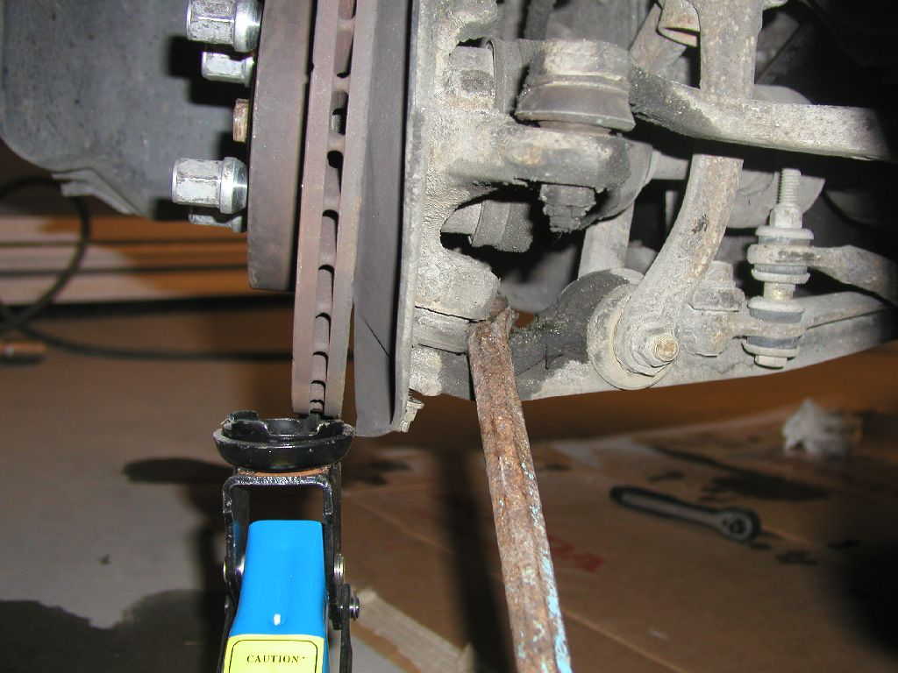
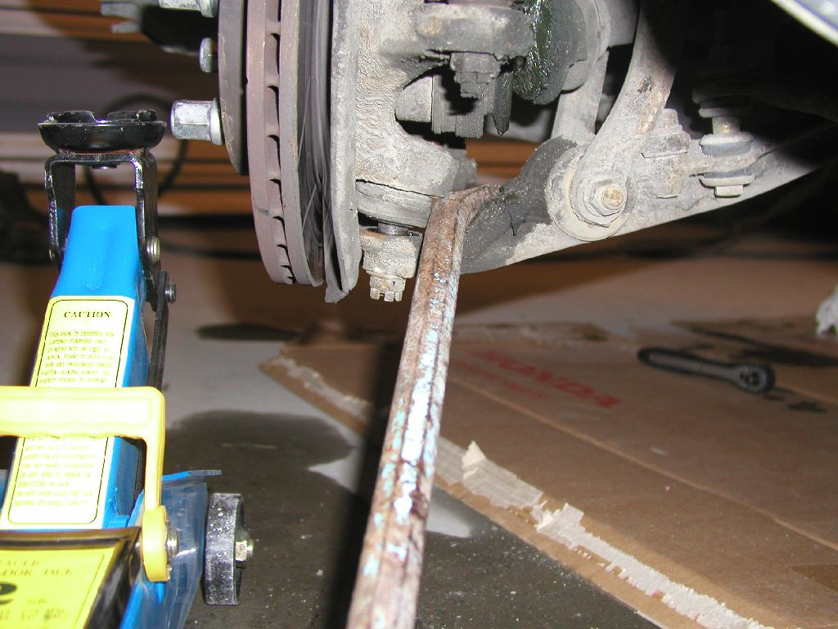
When the ball joint is removed you can loosen the lower fork. There's a 17mm bolt on the bottom and a 14mm on the back. It’s usually enough to remove the 17mm at bottom while leaving the 14mm on.

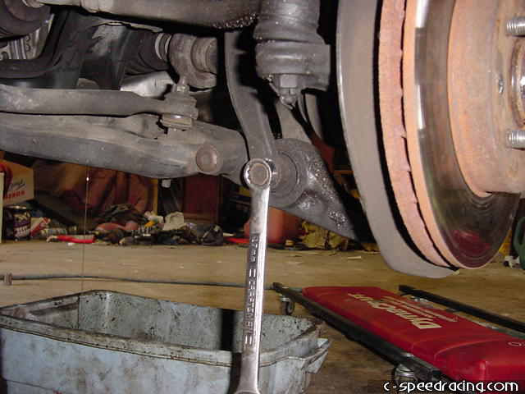

The inner half shaft is very simple to remove from the transmission. Just use a crow bar or a big screw driver to pop it out.

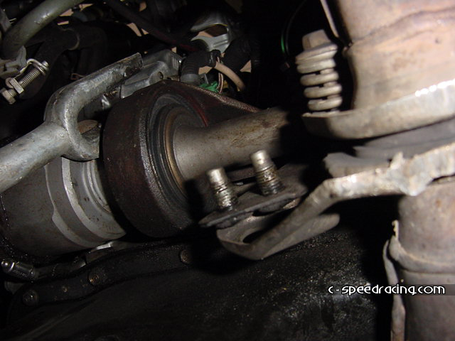

The left drive shaft should be possible to get out just by unscrewing the 3 14mm bolts that hold it, and just pull it out. If you need more room just remove the left ball joint the same way as the right one.

When you get the axels out, make sure to put some plastic bags around them to avoid them getting dirty. Stripsing the axels to something solid will keep them out of your way as well.
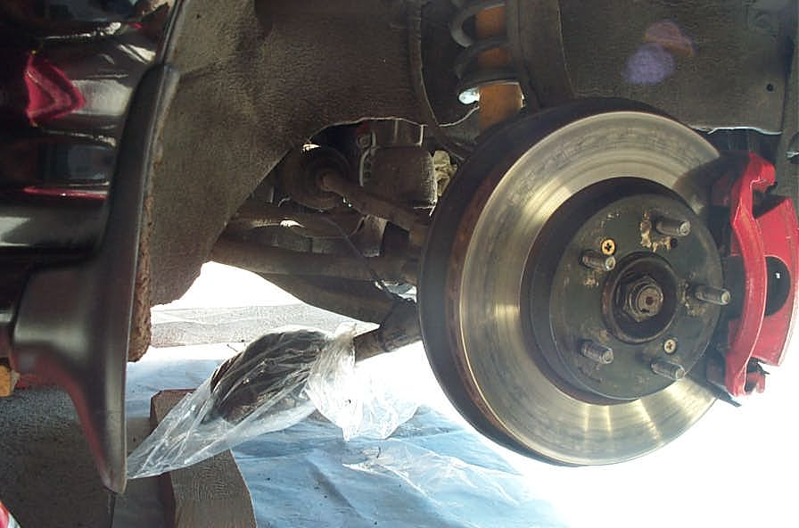

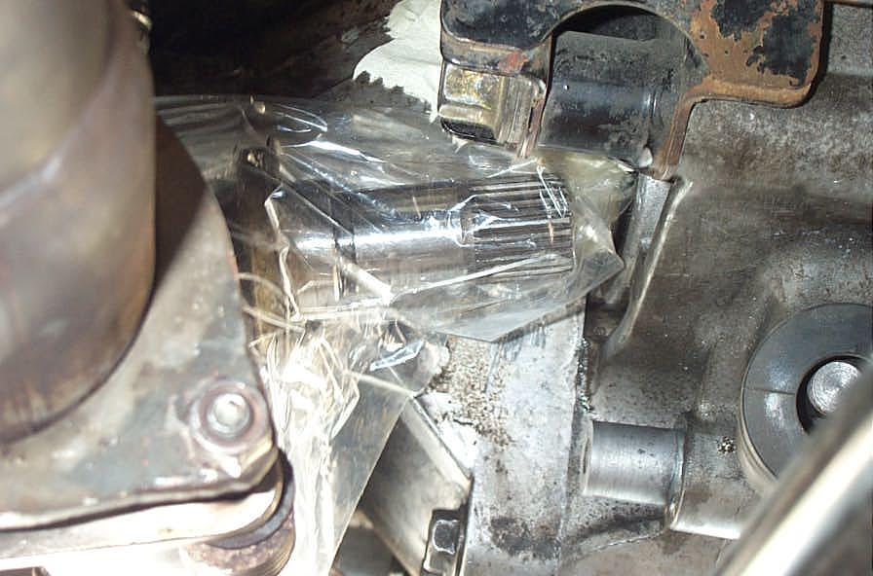

Or just use your imagination to keep the axels out of you way.

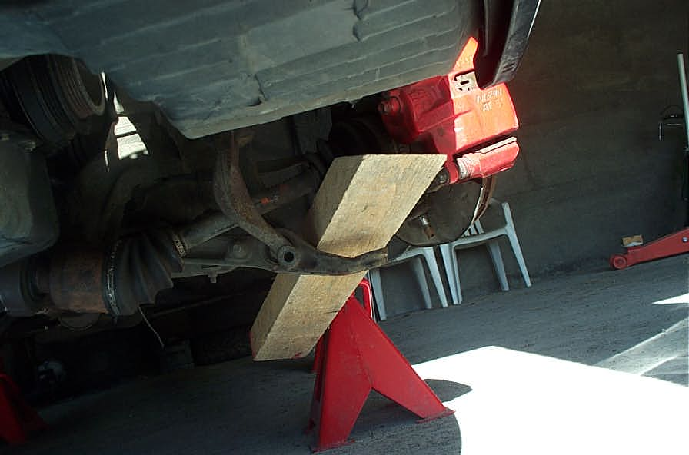

4: Remove the shift linkage.
To remove the shifter linkage, pull off the snap ring that covers the lock pin with a pair of pliers or a screwdriver, then with the correctly sized punch, hammer out the lock pin from underneath. Don't lose it!

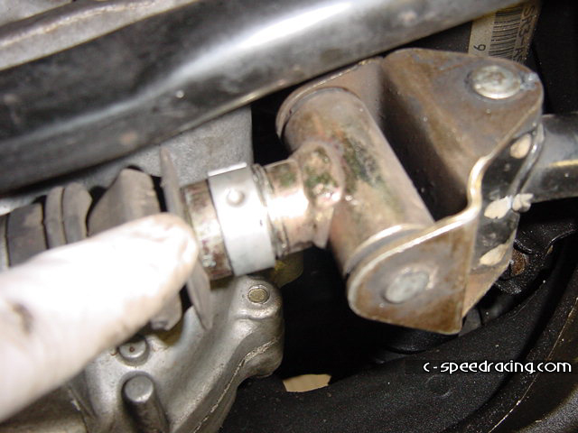
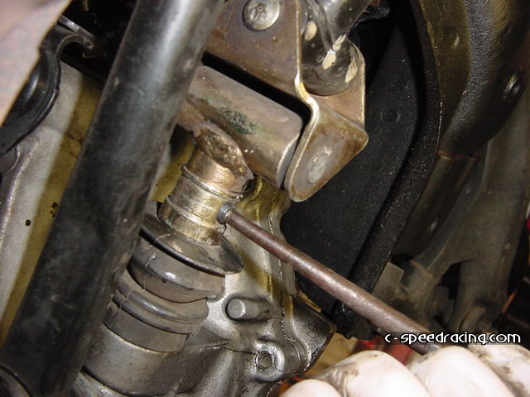
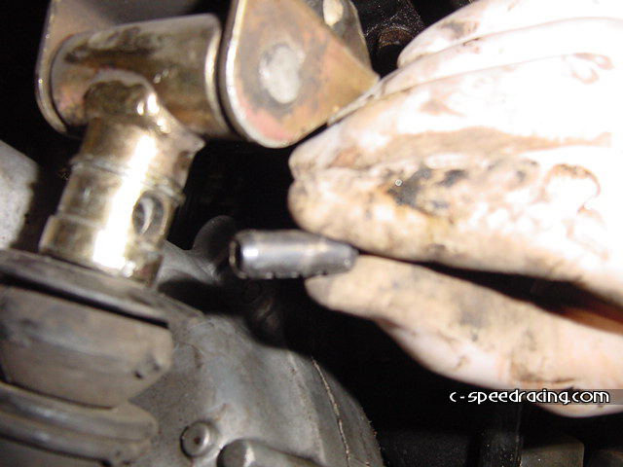

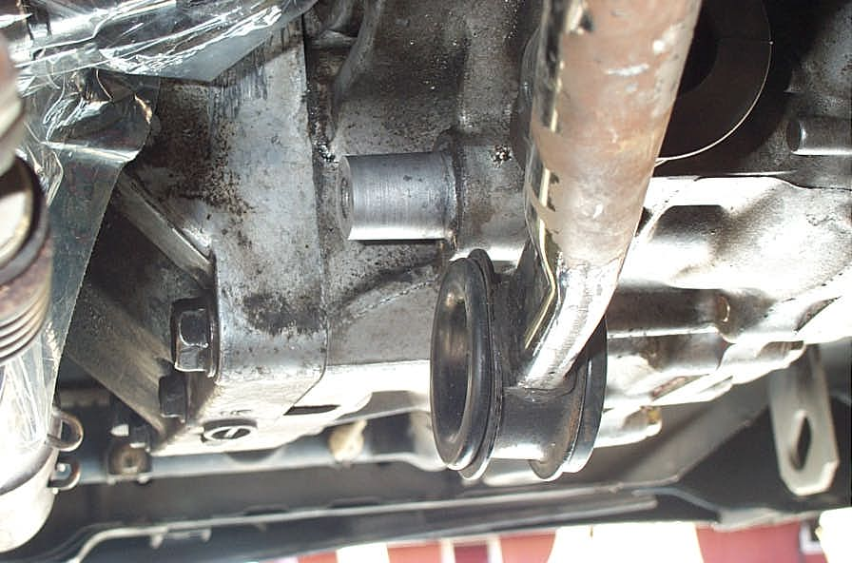

5: Remove the splash shield.
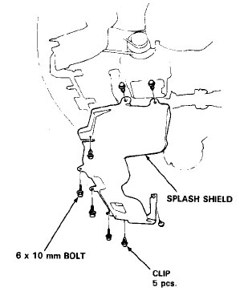

6: Loosen the exhaust.
Before you lower down the engine later on, it’s smart to loosen the rubber sleeves that hold the exhaust b-pipe to avid any tension on the exhaust.
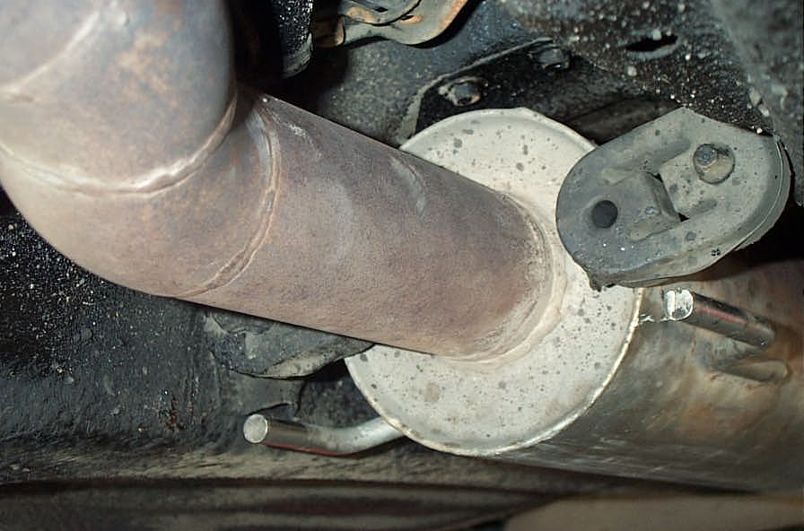
7: Remove the air intake.
Remove the air intake.

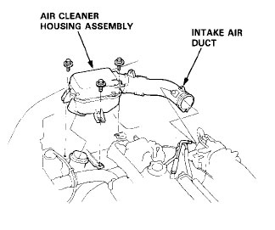

8: Remove the clutch slave cylinder.
Remove the clutch slave cylinder. There are two 14mm bolts. Be careful not to crush or bend the lines when you are maneuvering it around.

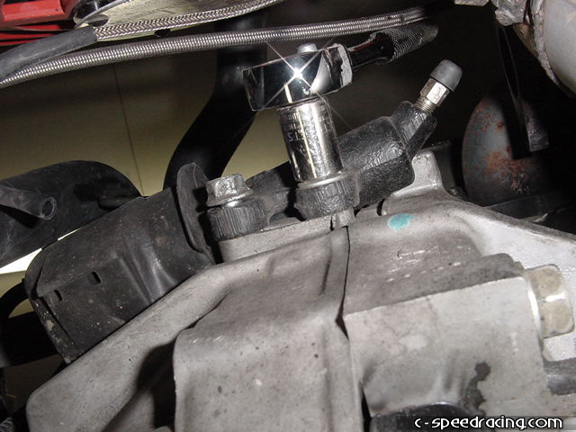
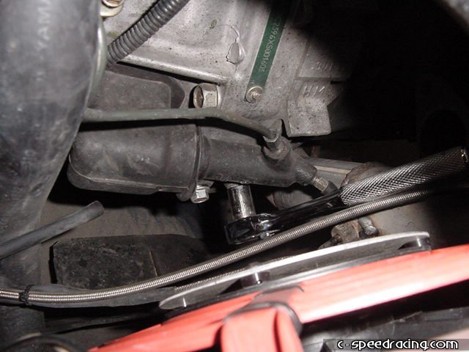
9: Disconnect all the wiring from the transmission.
Yank out all wiring and brackets that’s connected to the transmission. This includes ground straps on the transmission and the starter, as well as the VSS and a couple of brackets.

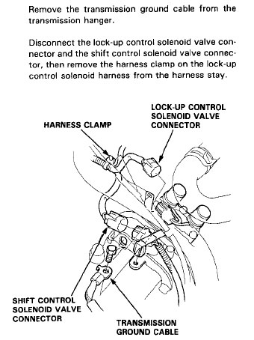

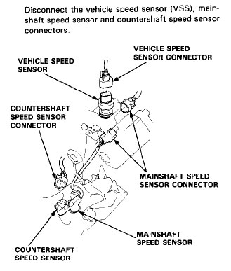
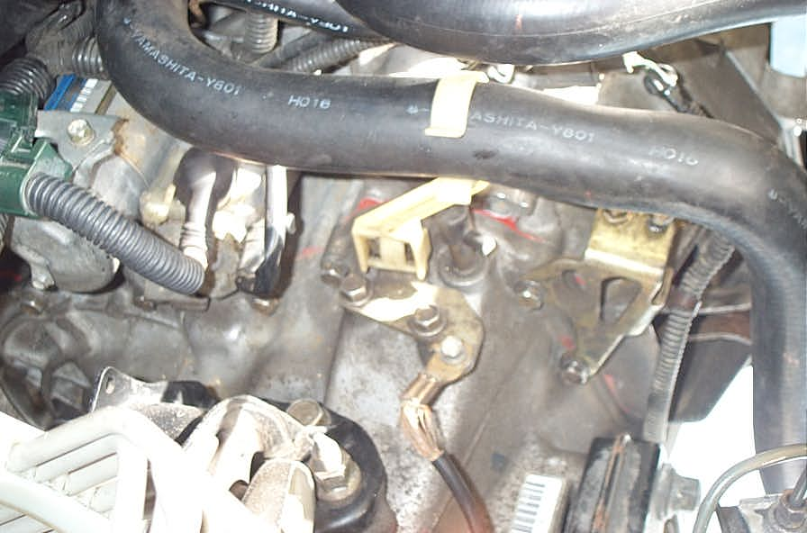

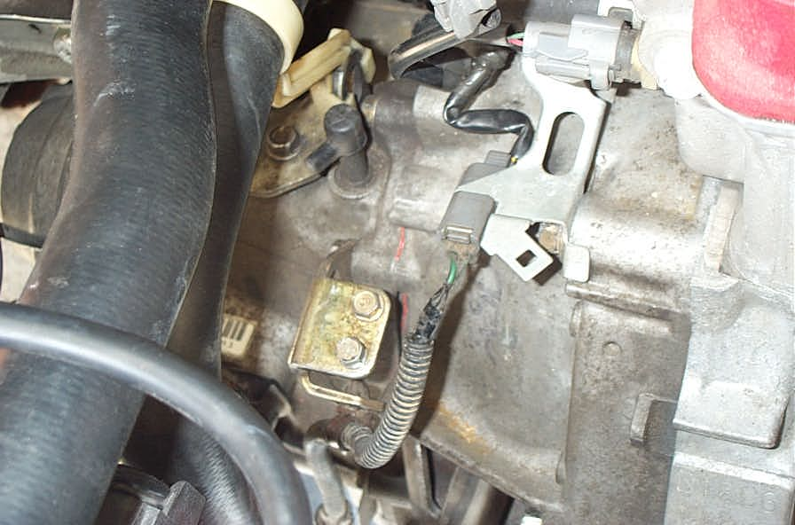

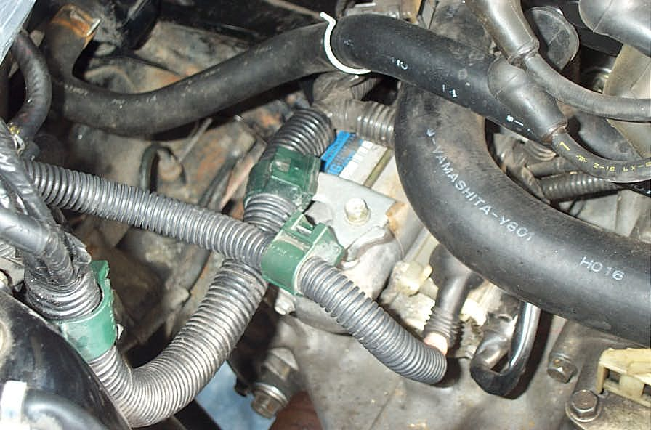

10: Remove the starter.
Remove the starter by taking out the two 12mm bolts, one is longer than the other. Make sure you disconnect the ground before pulling it out.

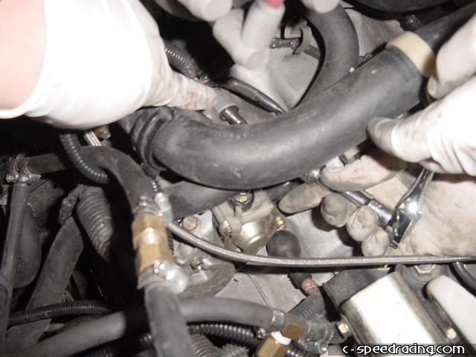

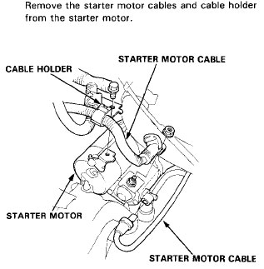

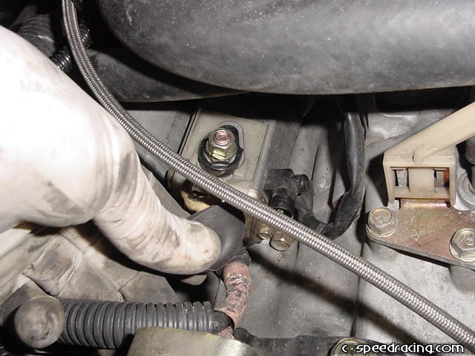

11: Remove the main bolts that hold the transmission to the block.
Remove all the main bolts that hold the transmission to the block. Remember to get the 17mm and 12mm bolts at the bottom of the transmission.
Below is a picture of the bolts you need to remove. You will need to remove the 12mm bolts at the center bottom even though they aren’t shown in the picture.
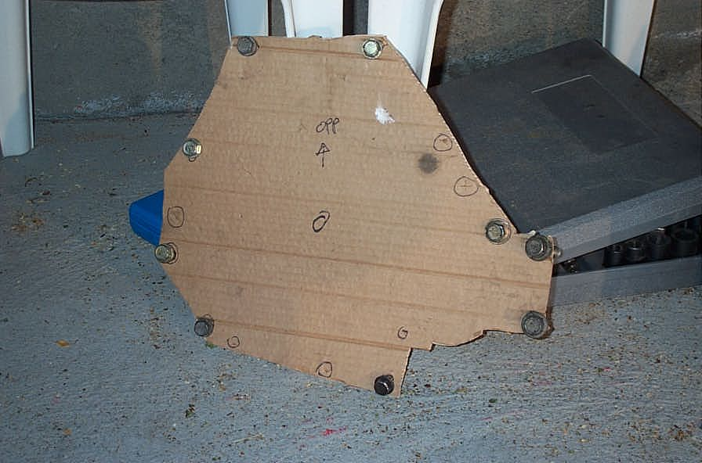

It’s smart to remove these bolts before you remove the engine mounts, because the engine will flex a lot when you remove them due to the force you need to apply.

12: Loosen the rear engine mount
Luckily you don’t have to remove the entire rear engine mount. It is enough to just loosen the two 19mm bolts holding the rear mount to the transmission. There is also an additional bolt that holds the mount to the frame on the other side.

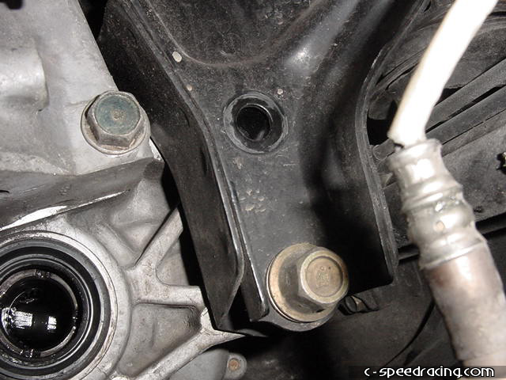

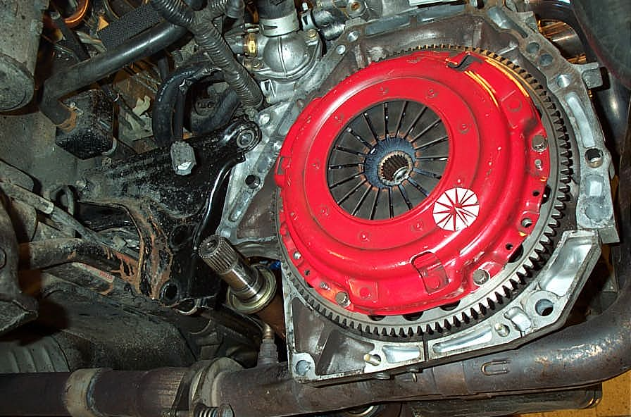

13: Place a jack under the engine.

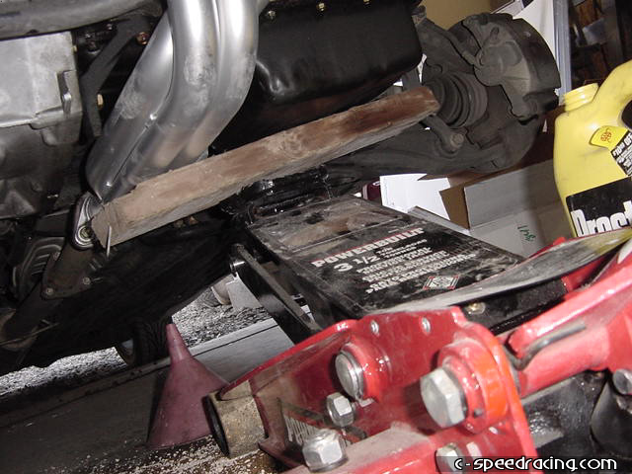

14: Remove the lower right engine mount.
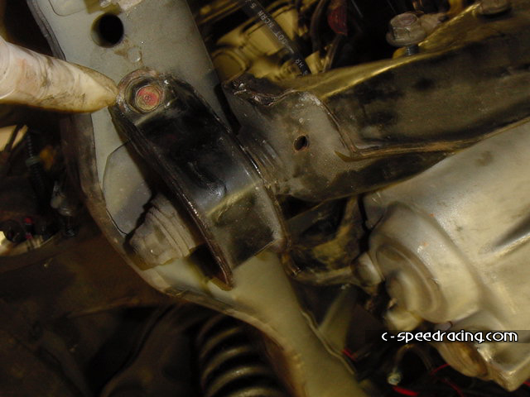
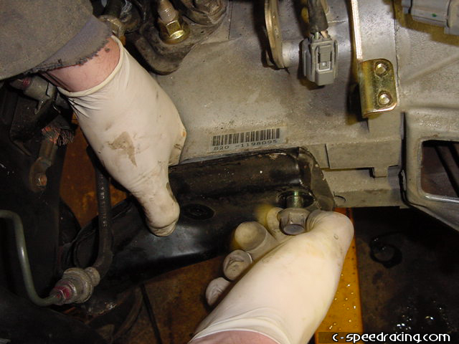

15: Remove the upper right engine mount.

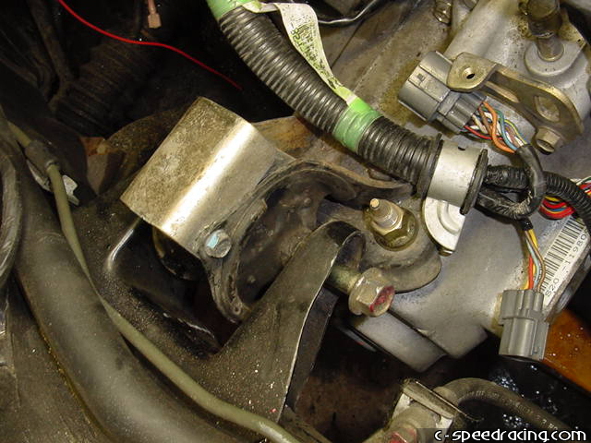

16: Loosen both the left engine mounts
You should loosen both the left engine mounts as well, to keep them from twisting too much when you lower the jack later on. The lower left engine mount can be removed all together, while the upper should only be loosened just a bit. This isn’t really necessary, but just a precaution.

17: Slowly let the motor drop down by lowering the jack until the motor sits sideways in the engine bay.
Slowly let the motor drop down by lowering the jack until the motor sits sideways in the engine bay. Be sure that you don’t lower it so much that the crank pulley comes in contact with the chassis.

18: Separate the transmission from the block and carefully lower it to the ground.
Then with the aid of a friend or two, have someone crawl under the transmission while another person separates the transmission from the block by using a flat screw driver. Carefully lower the transmission to the ground. Its not that heavy, approximately 30kg or so.

There are two small guide sleeves that are connected to the transmission. These make sure the transmission is aligned correctly against the engine. Make sure they don’t fall of as you drop the transmission.

19: Remove old throw out bearing
Remove the old throw out bearing by pulling firmly until it slides off the input shaft.

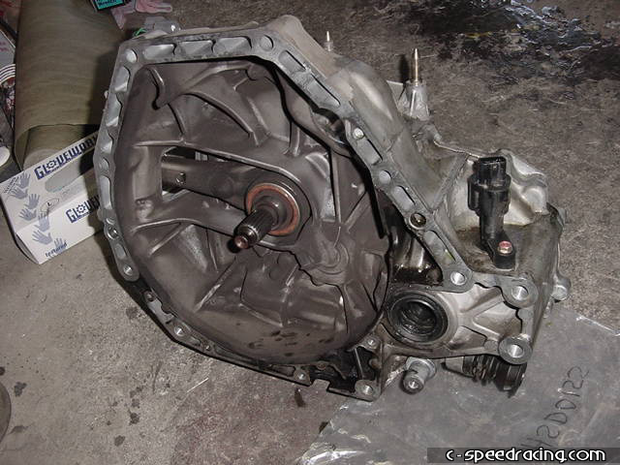
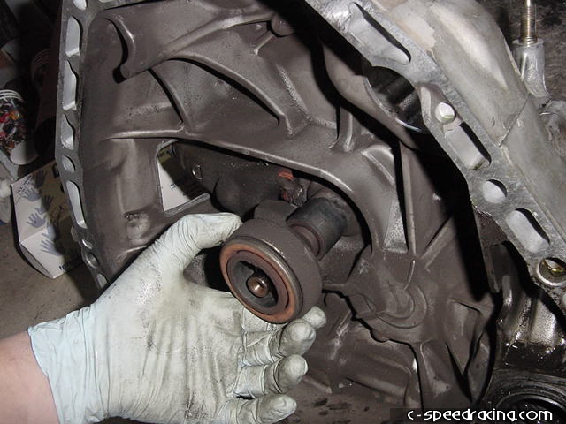
The throw out bearing is operated by an arm that is held onto a ball with a spring clip. Pull firmly towards the left and the arm will pop off as well. Clean the ball and socket on the arm.

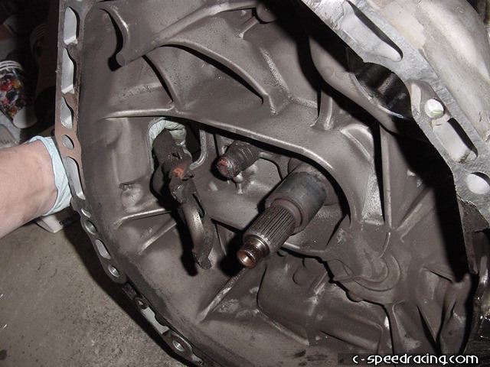
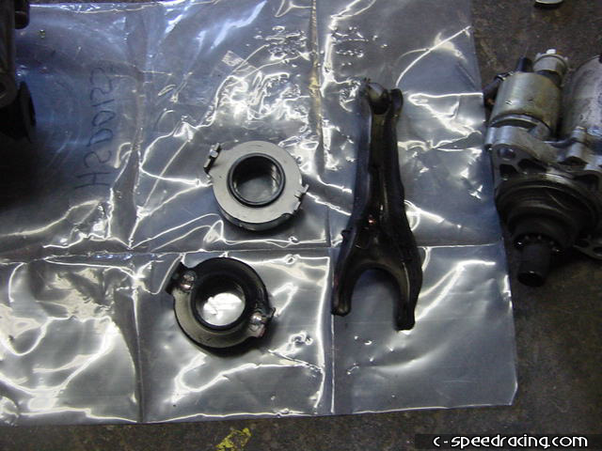
20: Install new throw out bearing
Before installing the new throw out bearing, be sure to grease the input shaft and throw out bearing where it contacts with the arm. Also grease the ball and socket that the arm rides on. Do not pack the throw out bearing with grease, it is prelubricated. Also do not clean it with any solvents.

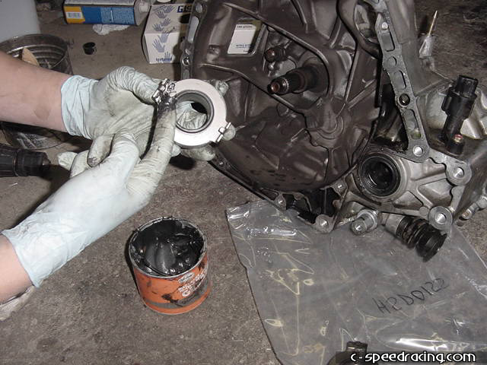
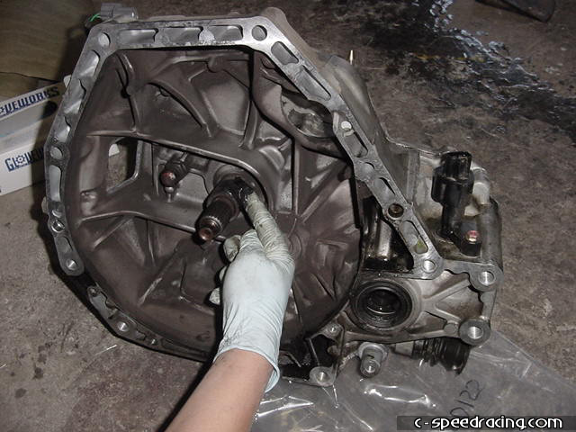
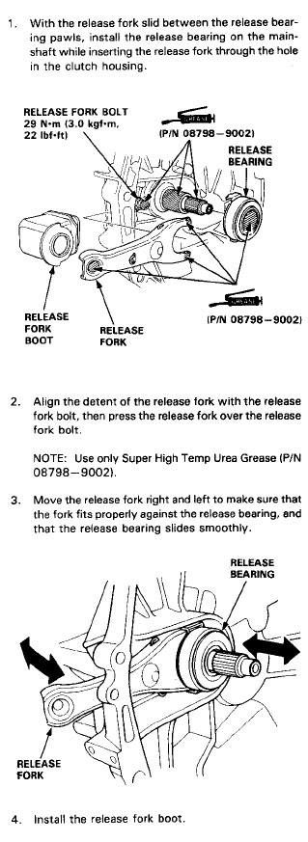
Reassemble the throw out bearing by inserting the arm back through the transmission housing first. Then slide the throw out bearing onto the input shaft while aligning it with the arm at the same time. Once in place, the arm should easily snap back over the ball and you’re done. Test the assembly by sliding the arm back and forth. The throw out bearing should slide easily along the input shaft.

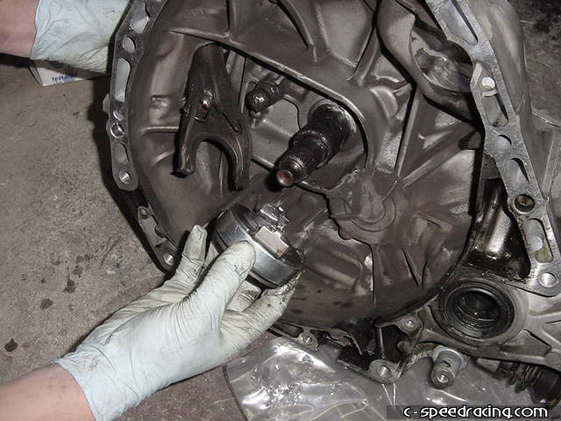
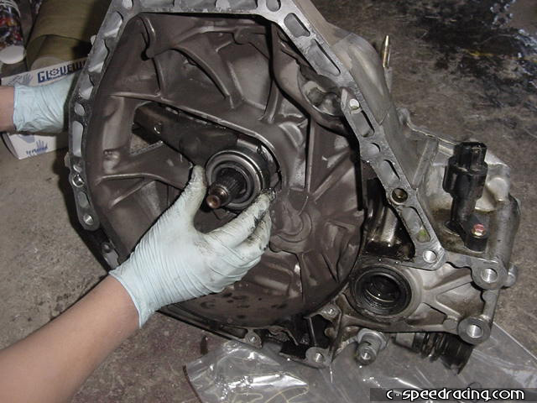

Once that task is complete, replace the transmission back on the block, and bolt everything back up the same way they were removed.

